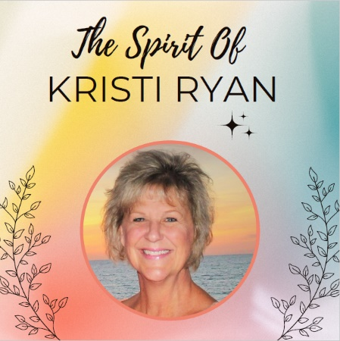The Spirit of Kristi Ryan

Award Nomination Form

2025

Date of Entry: ____________________________

Nominee Name: __________________________

**Attributes of The Spirit Of Kristi Ryan Award:**

* **Positivity:** Looks for the good regardless of the situation
* **Demonstrates Integrity & Respect to All Parties:** Has a negotiating attitude and is fair to all
* **A Knowledgeable Researcher:** Never assumes anything and finds answers
* **Great Communication Skills:** Can adapt to connect with all different personality styles
* **Keeps the Client’s Best Interest at Heart:** Doesn’t settle for less than what the client deserves
* **Emulates a Giving Spirit in All Things:** Will not do things out of selfish ambition

**Please concisely explain why this person deserves The Spirit of Kristi Ryan Award based on, but not limited to, the above attributes:**

__________________________________________________________________________________________________________________________________________________________________________________________________________________________________________________________________________________________________________________________________________________________________________________________________________________________________________________________________________________________________________________________________________________________________________________________________________________________________________________________________________________________________________________________________________________________________________________________________________________________________________________________________________________________________________________________________________________________________________________________________________________________________________________________________________________________________________________________________________________________________________________________________________________

The nominations for this award are to be emailed to meghann@sbarearealtors.org

no later than Monday, November 17th, 2025

Association members will vote on the nominees between December 8th and 12th.