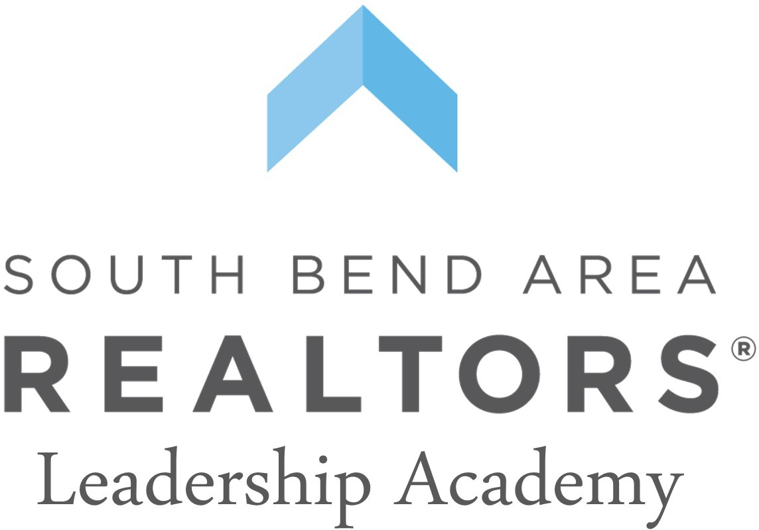

Leadership Academy Application

The development of the South Bend Area REALTORS Leadership Academy is designed to identify, foster, and educate active members of SBAR who have expressed their leadership interest and potential. Over the course of six sessions, participants will gain the tools necessary to be effective leaders within our organization and our community. Participants will learn how to best collaborate with others, local and state governance, and industry best practices, with a focus on elevating the foundation for future local leaders.

Name-
Work Experience-
Brokerage- Years Licensed-
Real Estate Designations/Certiﬁcations-
Career/Occupation prior to Real Estate-

Community Involvement- List community, civic, religious, political, governmental, athletic, social, or other areas of active involvement. Please note years of participation or service as well as in what capacity.

Short Response-
- What are the three most recent real estate related events you attended and participated in locally, state and/or nationally?

- In your opinion, what are the traits that make an eﬀective leader?

- Describe a leadership challenge you faced and what you did to overcome it?

- How do you demonstrate your ability to work on a team?

- Why did you apply for the leadership academy, and what do you hope to get out of this experience?

- Please share an experience in which diversity and/or inclusion has an impact on you and why?

- What is an industry related issue that you are passionate about? How do you hope to make an impact on the subject in the future?

Professional References
In determining the best-qualiﬁed Leadership Academy candidates, we ask that you submit two professional letters of recommendation. Preferably, one to be your managing broker.

